|  |  |
| --- | --- |
| Date | 14 November 2022 |
| Team ID | PNT2022TMID05082 |
| Project Name | Inventory Management System for Retailers |
| Batch number | B11-5A1E |

TASK

* **Create UI to interact with application**
  + Registration Page
  + Login Page
  + Display items in the Dashboard
  + Adding items
  + Test it

Create UI to interact with application

**Registration Page**

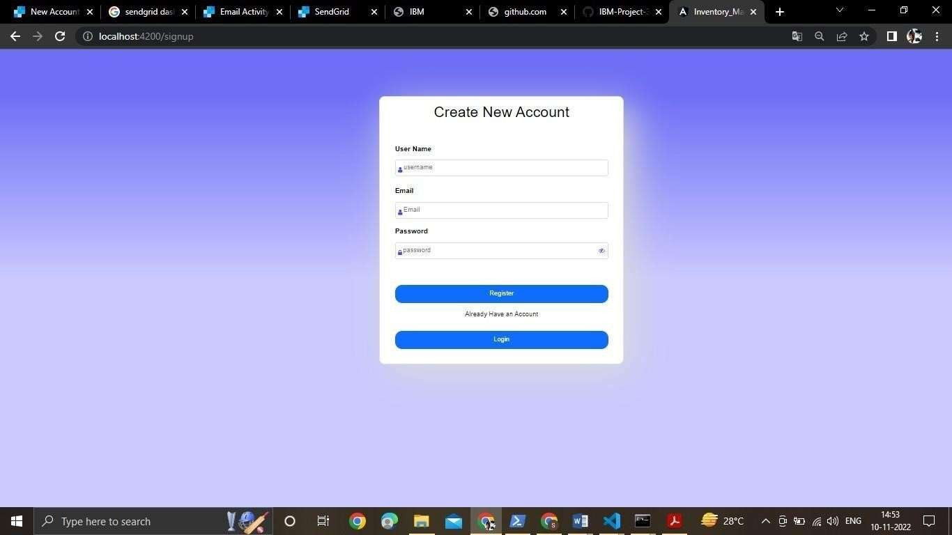

**Login Page**

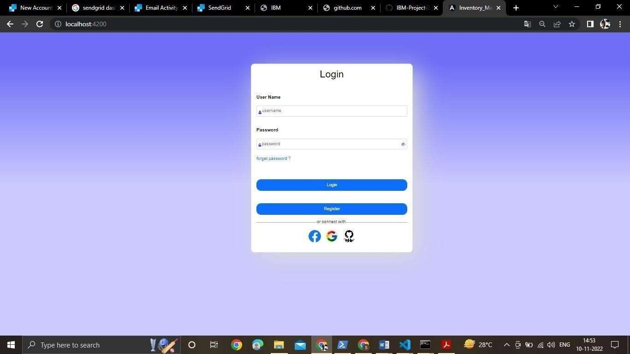

**Display items in the Dashboard**

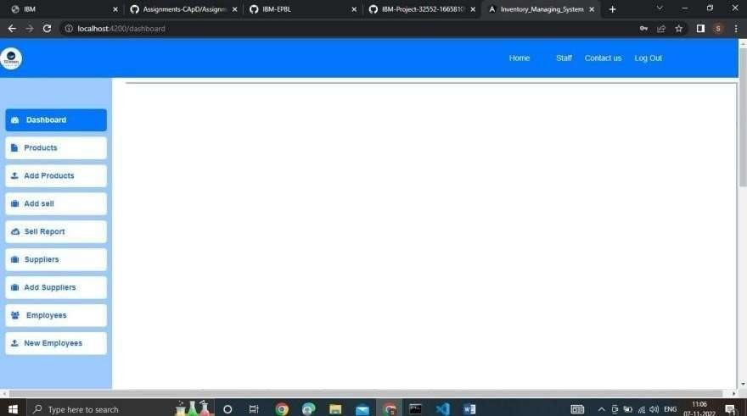

**Adding items**

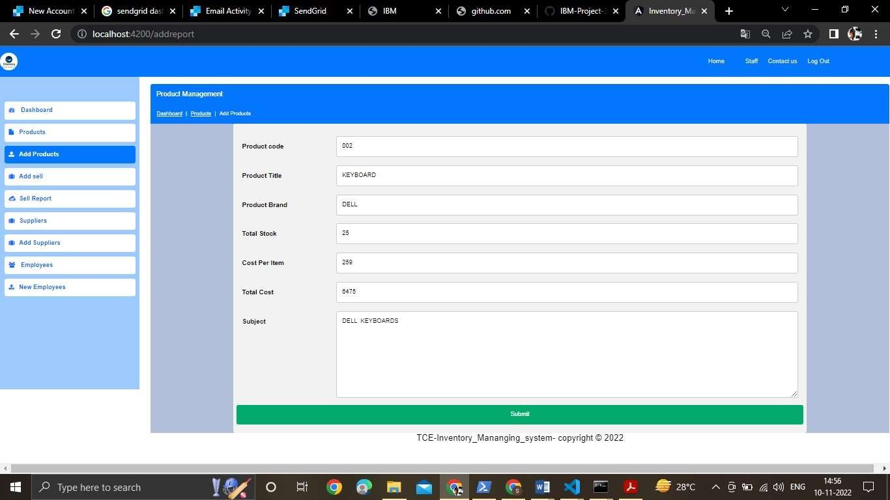

**Test it**

